# Collaborative Research: Browsing Intra-pacific Variability And Linked enVironmental Effects (BIVALVE)

1. **Intellectual Merit**

The Pacific Ocean is the earth’s largest reservoir of heat, driving interannual variability in temperature and rainfall anomalies in many parts of the world and mediating the rate of anthropogenic global warming on decadal timescales (Power et al., 1999; England et al., 2014; Dai et al., 2015; Salinger et al., 2020). The El Niño-Southern Oscillation (ENSO) is the single most important driver of interannual climate anomalies, bringing global changes in atmospheric circulation (Timmerman et al., 2018). ENSO drives global precipitation anomalies of up to 300+ mm/yr (Dai and Wigley, 2000), myriad extreme weather events (Santoso et al., 2017), and abrupt economic impacts (Cashin et al., 2017). On decadal timescales the Pacific Decadal Oscillation (PDO) is the primary source of variability in the North Pacific (Mantua et al., 1999; Newman et al., 2016).The PDO has been linked to variability in droughts, wildfire, snowpack, and heatwaves in North America (Benson et al., 2003; Dai, 2013; Hessl et al., 2004; Mantua and Hare, 2002; McCabe, 2013; Mote, 2006; Neal et al., 2002; Trouet et al., 2009), and a number of economically important fisheries (Anderson and Piatt, 1999; Conners et al., 2002; Hollowed et al., 2001). Unlike ENSO however, the PDO is best described as the integrator of several atmospheric and marine phenomena, a statistical rather than a physical mode (Newman et al., 2003; Schneider and Cornuelle, 2005; DiLorenzo et al., 2015; Newman et al., 2016). A better target for understanding the critical decadal variability of the Pacific is the Interdecadal Pacific Oscillation (IPO).

The IPO is a pan-Pacific phenomenon described by the temperature anomalies in three centers of action 1) the North-Central Pacific, halfway between the Kamchatka Peninsula and Hawaii, 2) the Nino 3.4 region, and 3) a region centered just to the north of the North Island of New Zealand (Fig 1; Henley et al., 2015). Like the PDO, the IPO integrates ENSO over time, however, the IPO is more symmetric about the tropics and better approximates a physical decadal mode than the PDO, offering better opportunities for forecasting (Meehl and Hu, 2006; Meehl et al., 2010). Because the IPO varies at decadal timescales, the sparse data in the Pacific prior to ~1950 presents a challenge to its understanding and a hurdle to improving its expression in climate models (Cassou et al., 2018). Several attempts have been made to reconstruct the IPO, but all of these reconstructions are limited by the absence of in-situ data from the northern or southern IPO regions (Linsley et al., 2008; Buckley et al., 2019; Godkin et al., 2021; Porter et al., 2021; Vance et al., 2022). Furthermore, all such reconstructions show poor agreement prior to 1950, leading the authors of the most recent IPCC report to give a rating of “low confidence” to paleo-reconstructions of decadal variability in the Pacific (Fig 2; IPCC, 2021), likely due to the reliance of these reconstructions on teleconnection patterns, which are the relationships with distant temperature and precipitation anomalies. Additionally, the IPCC authors note that evaluation of model skill in reproducing decadal variability of Pacific SSTs is hindered by a lack of data (IPCC, 2021).

The Southern Hemisphere contains few marine climate records which extend prior to 1950 and poor coverage by climate proxy records when compared with the Northern Hemisphere. In fact, no high-resolution, in-situ sea surface temperature proxy records exist for the period prior to the 20th century south of the subtropics (35°S). This lack of data presents a challenge when considering internal climate variability related to decadal timescale phenomena. A recognition of the paucity of high-resolution marine records has brought recent advances from marine bivalve research. For the PDO, a marine bivalve, the Pacific geoduck (*Panopea generosa*), is helping to fill an important data gap. A recent geoduck sea surface temperature (SST) reconstruction on the coast of British Columbia extends continuously from 1725-2008 CE and discontinuously to ~850 BCE, explaining 54% of regional SST variability (Edge et al., 2021). Similarly, important loci of marine variability in the South Pacific contain populations of closely related geoduck species, offering opportunities to add data in a critical action center of the IPO. This points to a promising avenue for new research.

In this proposal, called Browsing Intra-pacific Variability And Linked enVironmental Effects (BIVALVE), we propose to develop an annually resolved, multicentennial geoduck archive on the shores of New Zealand, using both growth increments and annual δ18O to reconstruct SST prior to instrumental records. This reconstruction will improve our knowledge of the natural range of SST variability in an under-studied region. Additionally, this will provide important missing data for reconstructing the IPO and understanding Pacific teleconnections to other parts of the world. In particular, we propose to:

**Figure 1. Tripole Index of the Interdecadal Pacific Oscillation in ERA5.** TOP: Correlation between the 10-year low-pass filtered annual Tripole Index and annual SST (over oceans) and precipitation (over land) in ERA5. Region 1: 25°N–45°N, 140°E–145°W; Region 2: 10°S–10°N, 170°E–90°W; Region 3: 50°S–15°S, 150°E–160°W. A collection of nearby bivalve, coral, and tree records are shown in symbols, with the proposed New Zealand bivalve site shown as a large symbol. BOTTOM: Time series of annual and 10-year low-pass filtered annual Tripole Index.

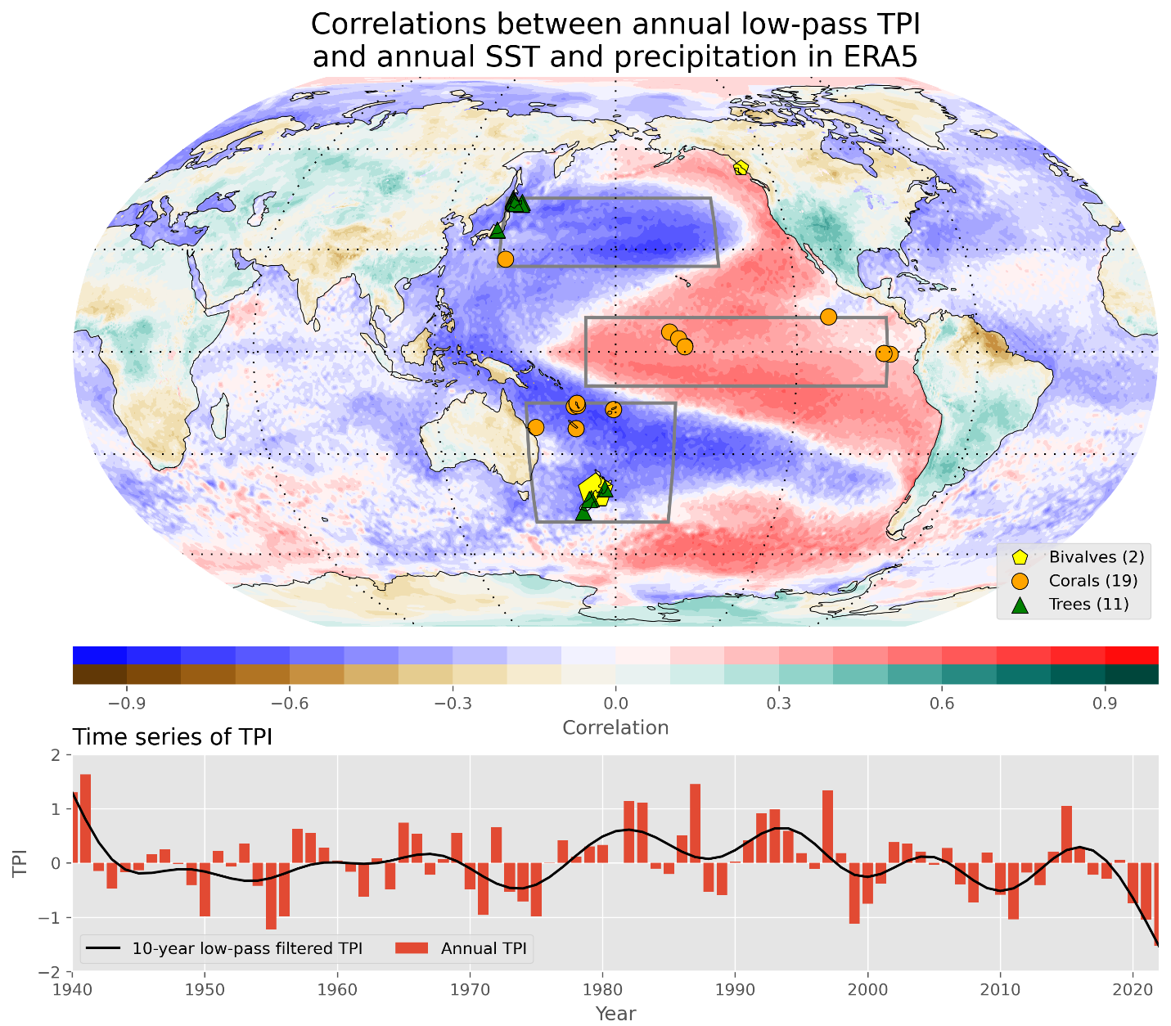

* Advance paleoclimate research by developing a proxy archive from a new species of marine bivalve, *P. zelandica*.
* Create the first high-resolution, in-situ marine proxy record of south Pacific SST variability, helping inform our knowledge of local climate near New Zealand over the past few hundred years.
* Reconstruct the Interdecadal Pacific Oscillation (IPO) from proxy records within the IPO critical regions (Fig 1)
* Explore teleconnections in data and models, and how these relationships may change in the future.

This BIVALVE project will help characterize Pacific variability near New Zealand—important for populations across the island nation—and, through comparisons with other datasets, help us explore climate interactions across the entire Pacific basin and beyond. The new data will also be used to evaluate climate simulations, providing insight about Pacific variability and teleconnections now and in the future.

1. **Background**

**2.1 Pacific Climate**

The Interdecadal Pacific Oscillation (IPO) is a basin-wide, quasi-regular alternation of spatial pattern of sea surface temperature (SST) anomalies (Power et al., 1999). Spatially, the IPO SST anomaly pattern resembles ENSO and may be largely driven by tropical Pacific variability at shorter timescales (DiLorenzo et al., 2015; Newman et al., 2016). The IPO is a major source of temperature and precipitation variability across the globe (Power et al., 1999; Mohino et al., 2011; Vance et al., 2014; Dong and Dai, 2015; Palmer et al., 2015) as well as Antarctic temperature and sea ice extent (Meehl et al., 2016; Turner et al., 2016; Clem et al., 2020). The IPO has also been linked to the decadal changes in global warming (England et al., 2014; Dai et al., 2015).

The region of the proposed work encompasses all shores of New Zealand, ranging from ~35-47°S, which is within one of the three nodes of IPO variability. Due to the small land area of New Zealand, the terrestrial climate is dominated by ocean temperatures (Bowen et al., 2017), which have been warming at ~0.1-0.3°C/decade since 1981 (Sutton and Bowen, 2019), affecting the marine ecosystem and fisheries around New Zealand (Neuheimer et al., 2011; Chiswell and Sutton, 2020; Lavin et al., 2022). Notably, the local secular trend in SST can be overwhelmed or enhanced for periods greater than 10 years by internal climate variability (Power et al., 1999). Decadal-scale SST variability around New Zealand is dominated by the IPO, and this climate index is a topic of interest for the government and people of New Zealand (Power et al., 1999; Salinger et al., 2020; Mullan et al., 2010). Due to the long-timescale nature of IPO variability, however, instrumental SST data is insufficient for its characterization.

Reconstruction of the IPO has been attempted by proxies from various archives including corals, trees, and ice cores (Fig 2; Linsley et al., 2008; Buckley et al., 2019; Godkin et al., 2021; Porter et al., 2021; Vance et al., 2022). While there is a general agreement among the reconstruction time series in the most recent interval of common overlap (1950-1996) with an average pairwise correlation of 0.66, this drops to only 0.38 in the prior 50-year interval (Fig 2). These reconstructions rely on observed teleconnection patterns to distant (primarily terrestrial) locales, but recent changes to the global energy balance may drive variability in these teleconnection patterns. The disagreement among existing reconstructions suggests that climate proxies from the IPO centers of action are needed to constrain uncertainty. The geoduck SST reconstruction developed in this project will provide the necessary data to better quantify the character of the IPO.

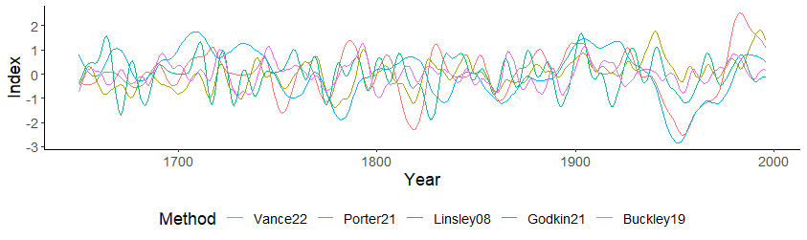

**Figure 2. Reconstructions of IPO.** Reconstructions truncated to common period of overlap (1650-1996) and normalized over this period. Displayed as 11-year spline fit for display purposes. Methods described in Linsley et al., 2008; Buckley et al., 2019; Godkin et al., 2021; Porter et al., 2021; Vance et al., 2022.

**2.2 Marine Bivalves**

The world’s oceans contain few in-situ marine, high-resolution (annual or better) paleoclimate records (PAGES 2k Consortium, 2013, 2017). Corals, the most common such archive, are limited to the tropics and subtropics (Grigg, 1982), with the southernmost coral record currently available from the NOAA paleoclimate database located at 32°S (retrieved Oct. 8, 2023). This limitation has been partially overcome in the northern oceans through analysis of long-lived marine bivalves which produce annual growth rings, but the south Pacific remains data sparse.

In the North Atlantic, annually resolved, calendar-year dated bivalve increments are increasingly utilized as high-resolution archives for reconstructing past marine circulation, productivity, temperature, and salinity (Butler et al., 2010; Wanamaker et al., 2012; Butler et al., 2013; Reynolds et al., 2017). Key to the precision of these archives is crossdating, where patterns of year-to-year growth are matched among organisms (Douglass, 1941; Stokes and Smiley 1996). By starting with living samples and crossdating backward in time, we can extend these chronologies well beyond the species' lifespan. Additionally, ring width measurements can be supplemented with density and isotopic data (Cook and Kairiukstis, 1990; Fritts, 1976). These species are long-lived (>100 years), the collections are highly replicated (10-30+ specimens/year), and collections are crossdated for assurance of calendar-year dating (Douglass, 1941; Black et al., 2019). Likewise, in the North Pacific bivalves such as the Pacific geoduck (*Panopea generosa*), are filling the high-resolution marine archive void (Strom et al., 2004; Black et al., 2009; Edge et al; 2021; Edge et al., 2022). Geoducks at many locations produce growth increments in relation to the ambient water temperature, allowing for straightforward reconstruction of sea surface temperatures from direct, in-situ archives.  Furthermore, a recent innovation in crossdating technique significantly reduces the time required for appending dead-collected specimens, allowing for the extension of records into the past, even with very short-lived (<40 years) specimens (Reynolds et al., 2021; Edge et al., 2021).

These innovations recently culminated in the reconstruction of SST (Edge et al., 2021) and ocean circulation (Edge et al., 2023) on the coast of British Columbia, Canada (Fig 3; award number 1855628). The underlying annual archive extends continuously from 1725 to 2008 CE and discontinuously back to circa 850 BCE. PI Thatcher is also involved in ongoing work that aims to fill in the gaps of this archive to achieve a continuous, millennial-length chronology - the first of its kind in the Pacific - which we will utilize in reconstruction the northern IPO region (Fig 1; award number 2303468). Little work of this nature has extended into the southern hemisphere, though a close relative of *P. generosa*, *P. zelandica* is shown to produce annual rings and longevity sufficient for crossdating (Gribben et al., 2005).

*P. zelandica* is similar to *P. generosa* in many important respects including longevity sufficient for crossdating, large populations in calm, subtidal water providing straightforward collection opportunities, and confirmed production of annual growth rings (Gribben et al., 2005; Gribben et al., 2015). A commercial fishery for *P. zelandica* commenced in the Austral summer of 1989-90 but was closed after three seasons over concerns of overfishing until reopening for substantial catches in 2008-09 which continues to present day (Ministry for Primary Industries, 2022). Research on the species has largely focused on the viability of the fishery, particularly using the analog of the commercially successful *P. generosa* fisheries in Washington, Alaska, and British Columbia (Breen et al., 1991; Gribben et al., 2005; Gribben et al., 2015; White et al., 2017).  *P. zelandica* are found to inhabit sand and mud sediments in shallow (10-25m) coastal waters, primarily in fine sand, similar to *P. generosa* (Breen et al., 1991; Gribben et al., 2005)*.* Growth rings are clearly visible for counting (Breen et al., 1991) and validated as annual by following known-age cohorts (Gribben et al., 2005; White et al., 2017). Our literature searches of *P. zelandica* uncovered no reports of attempted crossdating, nor any reports of known or suspected climate-growth relationships. However, we provide the results of pilot work which entails successful crossdating of *P. zelandica* (see section 3.1.2). The planned work also entails crossdating collections across a latitude/temperature gradient to locate populations ideally suited as climate archives based on the success of this method in *P. generosa* (see Methods; Black et al., 2009).

The location of *P. zelandica* populations is climatically sensitive, located within one of the tripoles of the Interdecadal Pacific Oscillation (Fig 1), and would provide climate proxy data at a crucial location.

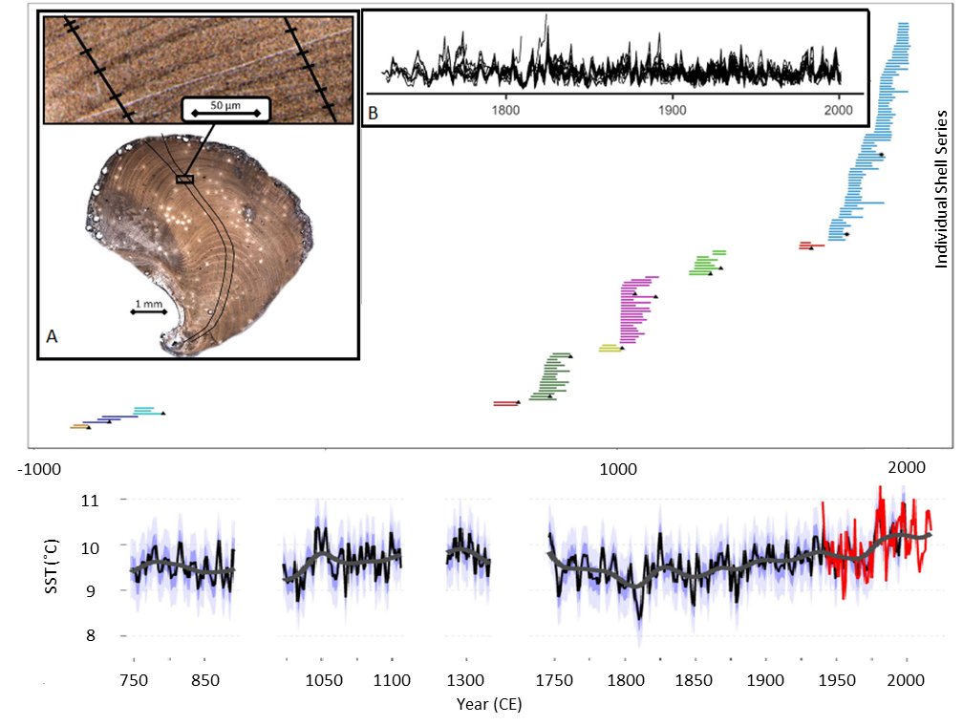

**Figure 3. SST reconstruction from North Pacific geoduck growth increments.** TOP: Tree Nob geoduck collection. Horizontal lines represent growth increment time series, while colors indicate crossdated sets. Black markers indicate radiocarbon samples. Inset A: two growth increment measurement series B: 114 detrended, crossdated growth increment time series BOTTOM: reconstructed SST for highly replicated time periods Adapted from Edge et al., 2021.

**2.3 Pacific variability and teleconnections in models**

To complement data from instruments and proxies, climate models provide a means to explore spatial and temporal relationships in the climate system. Data can be used to evaluate models and, in return, models can be used to make predictions about the future.

Due to its influence on climate in different parts of the world, including Southwest U.S. precipitation (Dai, 2013), Pacific SST variability has been a target of recent modeling work. In particular, Henley et al. (2017) compare the spatial and temporal characteristics of modeled Pacific variability against observational data in the HadISST2.1 (Titchner & Rayner, 2014). They focus on two types of simulations—preindustrial control and historical simulations—which provide a useful counterpoint to each other, as they constitute unforced vs. forced variability. Henley finds that, while the simulations do a reasonable job matching the spatial patterns of IPO variability, they generally overestimate interannual variability and underestimate decadal variability compared with the data. However, a noted limitation of this study is the relative lack of South Pacific climate observations prior to the satellite era, which started around 1979. This is a limitation that will be addressed in the present work.

Related to the IPO, the El Niño / Southern Oscillation (ENSO) has important teleconnections with temperature and precipitation across the world. Langenbrunner and Neelin (2013) compare a collection of Atmospheric Model Intercomparison Project (AMIP) simulations against teleconnection patterns in observations. They find that the models have some skill, but also considerable mismatch, in simulating precipitation teleconnection patterns. Nidheesh et al., (2017) explored the connection between ENSO and the PDO, showing that models tend to have too much lag between the two patterns. More recently, the IPCC (2021) showed that the most recent set of climate models (the Coupled Model Intercomparison Project Phase 6, CMIP6) performed better at simulating ENSO than CMIP5 in most respects (Planton et al., 2021), but acknowledge that the limited extent of observations produces uncertainty. This emphasizes the need for a longer set of annual observations in the Pacific, as proposed in this project.

1. **New and Proposed Work**

This project will develop a new in-situ SST proxy, providing crucial data for understanding the IPO. The first phase of the project involves gathering new and existing geoduck collections from 3 sites around New Zealand and evaluating growth increments and δ18O as climate proxies. The second phase involves extending the time interval covered by the most promising site by collecting dead specimens. We will develop a growth increment chronology from the newly extended archive and combine this with annual δ18O data from the same archive to develop a multiproxy SST reconstruction. In the final phase of the project we will reconstruct the IPO using our new geoduck SST reconstruction and several coral and tree-ring records. We will explore the character of past IPO variability, teleconnection patterns, and representation in climate models. Finally, we will assess the likely future patterns of the IPO and its impacts for terrestrial climate in the future.

**3.1 *P. zelandica* as an Archive**

**3.1.1 Existing Collections**

The age-structures of geoduck populations are important data for fisheries management. Because of this, several previous studies have collected, prepared, and aged geoduck collections from various locations along New Zealand’s coasts (Fig 4; Breen et al., 1991; Gribben and Creese, 2005; White et al., 2017). Paul Gribben shipped, and PI Edge received the Shelly Bay geoduck collection (n=112) on October 19, 2023 for further study (see letter of collaboration). An additional collection from Golden Bay consists of 665 individuals, which have been thin-sectioned and mounted on microscope slides. We have obtained the images, and Lindsey White has agreed to supply the original slides upon funding of this proposal (see letter of collaboration). All of these samples have been sectioned and polished for ring counting purposes, greatly reducing the work required to create crossdated chronologies.

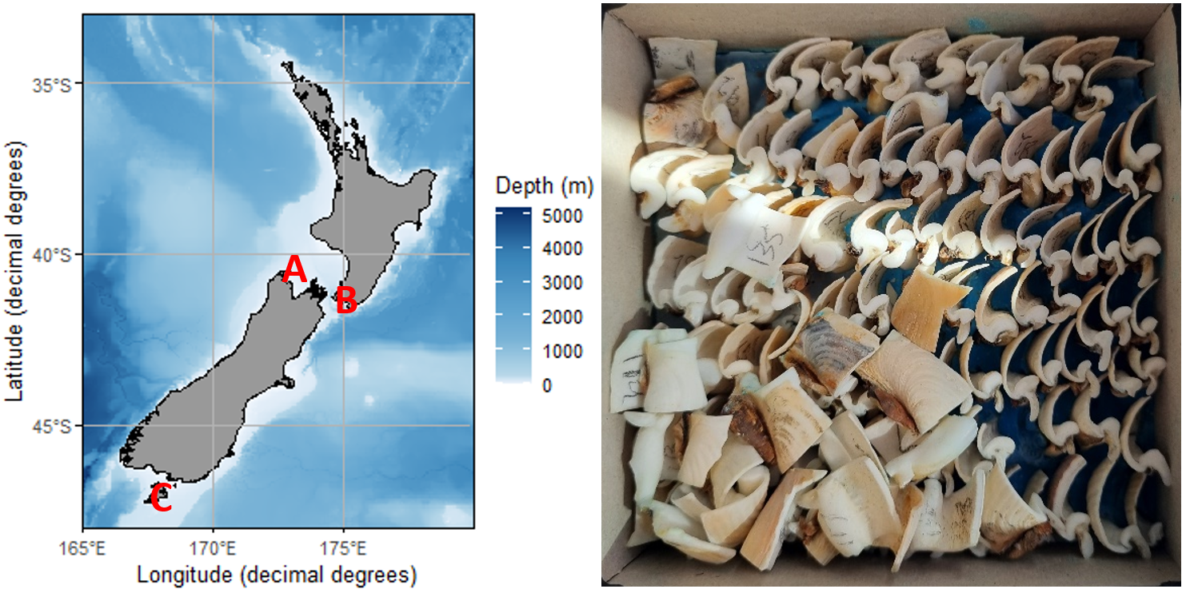

**Figure 4. New Zealand geoduck sites.** Bathymetry given by shading. A - Golden Bay, B - Shelly Bay, C - Paterson Inlet.

Lastly, we have been in contact with the primary geoduck fisher in New Zealand, PZL Harvesters. The owner/operator, Geoff Pacey, has agreed to send a diver to a new location to locate geoduck populations at Paterson Inlet, Stewart Island, an area in which the company already maintains a fishing quota (see letter of collaboration). If successful, this diver would return shells to our lab for processing and measurement, adding a location for our initial work. This collection would provide the southernmost data on New Zealand geoduck and offer climate-growth data from the coldest water of known populations.

To verify that the New Zealand geoduck are amenable to crossdating, their growth increments covary with water temperature, and the local ambient water temperatures covary with broad-scale SST, we have conducted a pilot study, as described in the next section.

**3.1.2 Pilot Study**

A Master’s thesis originating from Auckland University of Technology contains nearly 700 images of *P. zelandica* growth increments and associated metadata (White et al., 2017). White et al. collected geoducks from Golden Bay between September 2014 and August 2015. Shells were thin-sectioned at the umbo (apex of the hinge region), polished, and mounted on microscope slides. The thin sections were imaged under reflected and transmitted light dependent upon optimal ring visibility for each specimen. The collection of resulting images used for aging was presented as an appendix (White et al., 2017). Although these samples were not etched and peeled for optimal growth increment visibility, a few of the images are clear enough for ring measurement.

As a preliminary exploration of the samples, we measured the growth increments of three shells. These samples were chosen for the clarity of the growth increments, including the final increment, known by the date of collection. After crossdating these ring-width series, we detrended each series by fitting a cubic smoothing spline of 50% frequency cutoff and a wavelength of 0.67x the series length. Finally, the crossdated, detrended series were combined to form a chronology using the robust bi-weight mean (Cook and Kairiukstis, 1990). The resulting pilot chronology for Golden Bay geoduck is 19 years in length, with an average annual sample size of 2.2 shells.

**Figure 5. Chronology correlations and extensions.** TOP: Correlations of growth increment chronologies to Pacific SST. Collection locations denoted by black stars. Shading denotes significant pearson correlation (p < 0.01). A: *P. zelandica* from Golden Bay, New Zealand, Oct-Mar, 1996-2014. B: *P generosa* from Tree Nob, Canada, Apr-Oct, 1900-2000. BOTTOM:Simulated Shelly Bay Crossdating. Horizontal lines represent individual shells.

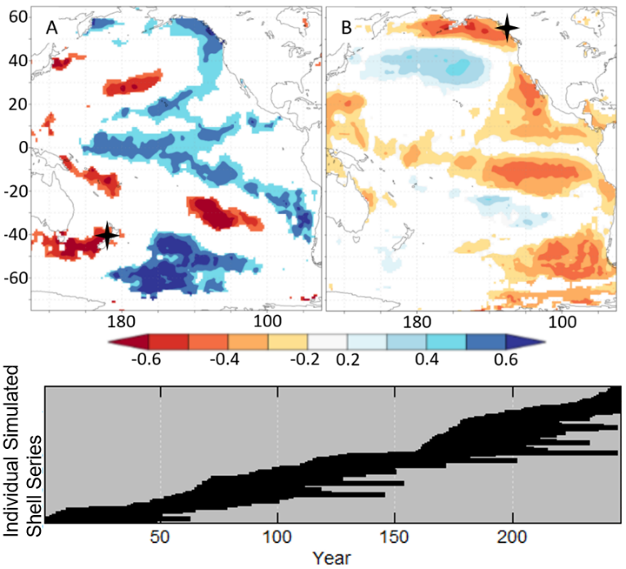

As this chronology is too short for rigorous climate-growth relationship analyses, we tested a growing season and water temperature relationship analogous to *P. generosa*. Therefore, we ran a climate field correlation analysis between the chronology and Pacific Basin SST for October-March over the duration of the chronology, 1996-2014 (Fig 5A; HadISST; Rayner et al., 2003). The resulting correlation map shows strong positive correlations (≥ 0.6) between the Golden Bay *P. zelandica* chronology and local SST. The shape and sign of the correlations across the Pacific basin closely resemble the IPO, with positive correlations to the western North Pacific and negative correlations to the tropical Pacific.

To assess the potential of the Golden Bay geoduck chronology to capture larger Pacific basin SST trends relative to the proven potential of *P. generosa*, we compared our correlation maps with analogous maps for the Tree Nob (N. Pacific) geoduck chronology. The relationships between the Tree Nob chronology and the broader Pacific are complementary to those of the Golden Bay chronology (Fig 5B). The inverse relationship between SST at the Tree Nob and Golden Bay sites, the opposing months of climate sensitivity, and the locations relative to the IPO regions of interest suggest they will together inform pan-Pacific SST reconstruction (bivalve locations in Fig 1, Fig 5).

**3.1.3 Chronology Development**

Expanding on the success of our pilot study, we will crossdate live-collected shells and build growth increment chronologies from 2 existing sites, as well as a potential new site. Crossdating the shells will require capturing high-resolution images from the shell hinge area, typically an area of ~10mm square. The existing samples have already been cut and polished to expose this region for ring counting. Resurfacing will consist of polishing samples on a grinding wheel with 1400- grit paper followed by 3-micron diamond paste. Polished samples will be etched with 0.1 molar HCl to enhance the contrast of growth lines. Finally, a small amount of acetone will be pipetted onto the shell and an acetate peel will be used to capture an impression of the surface, which will be mounted on a microscope slide (Richardson, 2001; Edge et al., 2021).

The acetate peels will be imaged with transmitted light using a stereo microscope. In order to measure growth increments of 10 microns or less, images will be captured at 80x or higher magnification and the resulting collage stitched together using Adobe Photoshop. The growth increments will then be measured twice for each shell using the dendrochronology application Coo-Recorder (Larsson, 2003). The resulting growth increment width time series will then be crossdated using RingdateR (Reynolds et al., 2021). Finally, the time series will be detrended using regional curve standardization to capture low-frequency variability (Fig 3; Briffa and Melvin, 2011) and combined into an average growth increment chronology (or simply, ‘chronology’) using the dendrochronology program library, dplR (Cook and Kairiukstis, 1990; Bunn, 2008).

Bryan Black has offered to host PI Edge at the Laboratory of Tree-Ring Research to refine the above methods. Dr. Black has pioneered and improved the laboratory methods and crossdating of many marine species including *Panopea generosa* (see letter of collaboration).

**3.1.4 Stable Isotopes**

In addition to the chronologies, which will quantify SST variability, we will develop further climate proxy data by sampling for stable isotopes. The stable isotopes will provide complementary SST data, allowing for a multiproxy reconstruction, and salinity data similar to the annually resolved δ18O records from multiple species of North Atlantic bivalves which have provided proxy records of both water temperature and salinity (Reynolds et al., 2017a; Reynolds et al., 2017b). The proposed research is the first application of *P. zelandica* for paleoclimate reconstruction using stable isotopes. Others have investigated oxygen isotopes in the close relative, *P. generosa* (incorrectly called *P. abrupta* in literature prior to 2010*,* Vadopalas et al., 2010), with inconsistent results (Goman et al., 2008; Hallmann et al., 2008, Nielsen and Neilsen, 2009). Results from two of these manuscripts support the idea that shell oxygen isotopes are precipitated in equilibrium with seawater and are related to temperature and salinity, a finding not corroborated by the other work since water isotopes from the collection site were not analyzed. It is well established from other bivalves (e.g. Epstein et al., 1953; Weidman et al., 1994; Wanamaker et al., 2006) that the δ18Oshell is a function of both water temperature and δ18O of the seawater (δ18Osw, related to salinity) and we expect a similar relationship in *P. zelandica*. The focus of initial shell sampling will be time periods that overlap the local instrumental record (1953-present) to confirm the relationship of δ18O with salinity and SST in *P. zelandica*. Additionally, a salinity-δ18O mixing line from this region will be developed with water samples from Paterson Inlet (e.g. Smith et al., 2005; Whitney et al., 2020) and a second mixing line at the collection location of the dead shells which will allow us to isolate the SST signal from the δ18Oshell record.

We will sample ~42 annual increments from each of four shells at each site plus an additional ~42 increments from each of four dead-collected shells between two instruments, with a high level of replication across shells precipitated in the same year and between two instruments (total isotopes = ~672). At Iowa State University, we will use an Elemental Scientific Lasers micromill (MM2) and a Brasseler USAV scriber point (item #H1621.11.008) and the samples will be analyzed for δ18O using a ThermoFisher Delta V Plus mass spectrometer coupled with a GasBench II with a CombiPal autosampler. The implementation of this technique in geoduck has been prevented by the lack of clear growth increment boundaries in the shell margin, however, new high precision instruments allow for isotope sampling at the 1-10 micron scale (WiscSIMS) This advance allows for the annual sampling of clearly visible geoduck increments in the hinge area, including the smallest expected annual increments of ~5 microns (Linzmeier et al., 2016; Linzmeier et al., 2018). We will use both facilities for stable isotope sampling - Iowa State University for larger increments and WiscSIMS for smaller - with replication of 5-10 medium sized increments on both devices. An additional ~308 isotope samples will quantify ocean variability in portions of the geoduck archive that lack sufficient replication for SST reconstruction from the ring width chronology.

At Paterson Inlet, divers under the direction of PI Edge will collect 25 water samples. The salinity and δ18O of these water samples will form the basis of a local mixing line. This process will be repeated with 25 water samples at the dead shell collection site. At the other site where we will not be collecting shells or water and developing a more local salinity-δ18O mixing line is not possible, we will use these new mixing lines to better understand the relationship of salinity-δ18O in the south Pacific.

These isotope analyses will go from proof of concept to full proxy development and relies on the following tasks for developing a robust multiproxy paleoclimate reconstruction: 1. Replication across contemporaneous shells 2. Development of multiple δ18O-salinity mixing lines to deconvolve salinity effects in δ18Oshell and 3. Overlap of the δ18Oshell record with instrumental SST and sea surface salinity (SSS) data. When complete, these robust, annually resolved, multi-proxy (chronology and δ18O) SST records have the potential to inform about present and past oceanographic variability as well as elucidate the behavior of the IPO prior to the instrumental record.

**3.1.5 Climate-Growth Relationships**

The geoduck chronologies and δ18O will be analyzed for climate-growth relationships using classical dendrochronology techniques (Fritts, 1976). The chronology and δ18O time series from each site will be compared with local monthly SST and SSS records using correlation function analysis in treeclim (Biondi and Waikul, 2004; Zang and Biondi, 2015). The strength and stability of these relationships will be a key site-selection criterion for extension with a dead collection.

**3.2 New Zealand and South Pacific Climate Variability**

**3.2.1 Geoduck Dead-Shell Collection**

The site selection for the first dead-collected sampling of Pacific geoduck produced the longest marine-based, annual resolution archive of SST in the northeast Pacific. The basis for sampling at this site (Tree Nob, British Columbia, Canada) was 1) great longevity, 2) strong climate growth relationship, and 3) presence of dead shells (Black et al., 2009; Edge et al., 2021). We will follow this model in selecting which of our 3 sites to extend.

The dead-shell collection will be performed by professional divers from the New Zealand geoduck fishery. The diver will extract geoduck from the sediment using a water jet. PI Edge will be present for this harvesting to assess longevity, provide feedback on collection quantity and location, and document the environmental conditions. This harvest will include approximately 600 shells for extension of the archive.

The dead shell collection will extend our live-collected geoduck archive. The length and continuity of the final archive will depend on the longevity and antiquity distributions of the harvest. Longevity of *P. zelandica* is not well established, though initial age distributions suggest the species is shorter-lived than *P. generosa* (Gribben and Crease, 2005; White et al., 2017). The Shelly Bay collection contained an 85 year-old shell and 10% of the shells were >40 years old. The recent advancements in crossdating alongside strong increment width covariability among individuals allows for crossdating of 30-year-old, dead-collected individuals (Reynolds et al., 2021; Edge et al., 2021).

To estimate the number of shells required to build a multicentennial record from *P. zelandica*, we simulated the potential antiquity from the Tree Nob collection and longevity from the Shelly Bay *P. zelandica*. We used only the shells of 30+ years longevity, near the minimum segment length required for crossdating geoduck. We simulated crossdating by resampling from the 29 longevity values ranging from 30-85 years (26% of Shelly Bay samples), assigning antiquity based on the distribution of ages in the Tree Nob chronology. When doubling the number of dead-collected shells in the Tree Nob chronology, the simulated Shelly Bay dead-collected demonstrates ample annual sample size (min 10) and overlap for crossdating (min 30; Fig 5). The ~154 shells required would necessitate a dead shell collection of ~600 shells based on the age distribution of live-collected geoduck. The range and distribution of antiquities of dead shells from the seafloor is difficult to anticipate, and long-dead shells may be more common than recently dead in some cases. The antiquities of dead shells do tend to cluster, however, allowing for windows into past marine variability from annually resolved proxies (Scourse et al., 2006; Edge et al., 2021).

**3.2.2 Floating Chronologies and Radiocarbon**

The completed crossdated archive will likely consist of “floating chronologies”, crossdated geoduck which do not overlap with the live-collected record. The floating chronologies can provide valuable snapshots of the climate at more remote times (Scourse et al., 2006; Edge et al., 2021). Dating of floating chronologies will be accomplished by paired radiocarbon samples taken at the maximum temporal distance within the floating chronology. We will sample each of the floating chronologies at two distinct time intervals, from two different shells using the Iowa State micromill as described in section 3.1.4. We will implement a Bayesian “wiggle matching” approach in OxCal to refine the 14C age estimates and uncertainties using the paired radiocarbon probability distributions and their respective known sclerochronological offsets (de Vries, 1958; Ramsey et al., 2001). The local radiocarbon reservoir effect will first be established by sampling radiocarbon from 3 unique time intervals in the live-collected, absolutely dated chronology (Lower-spies et al., 2020). All radiocarbon samples will incorporate 10 years of shell growth to reduce impacts of interannual variability in marine radiocarbon and will be run at the ACE Isotope Lab, Northern Arizona University (Edge et al., 2023).

3.3.3 Marine Climate Reconstruction

The extended archive, including well-replicated floating chronologies will be used to reconstruct SST prior to instrumental records in the region. The extended growth increment chronology is likely to provide a proxy for SST based on prior work with *P. generosa* and the results of the *P. zelandica* pilot study (Strom et al., 2004; Black et al., 2009; Edge et al., 2021; Fig 5). The δ18O will provide an independent dataset from the same location, potentially providing a complimentary SST proxy or offering a SSS proxy for a distinct reconstruction of water mass dynamics. Our new reconstruction(s) will adhere to best practices for model fit using the Akaike information criterion (Venables and Ripley, 2002), calibration verification using the autocorrelation-corrected coefficient of determination (Macias-Fauria et al., 2012), and fully propagated uncertainties (Edge et al., 2021).

**3.3 The Interdecadal Pacific Oscillation**

**3.3.1 High-Resolution Proxies of Pacific SST**

The IPO Tripole Index (TPI, Fig 1) offers clear targets for proxy reconstruction in the form of SST anomalies in 3 regions of interest (Henley et al., 2015). The new geoduck SST reconstruction will be an important addition to the Southern Region (50°S–15°S, 150°E–160°W) wherein corals provide SST reconstructions in the north and coastal trees provide closely related air temperatures in the south (Fig 1). Tropical corals previously used to reconstruct ENSO, at Palmyra, Kiribati, and Galapagos will be used to capture the Tropical Region (10°S–10°N, 170°E–90°W). The Northern Region SST anomalies will be the most complicated region to reconstruct. There is only a small region at the far western portion of the Northern Region (25°N–45°N, 140°E–145°W) containing temperature sensitive, annually resolved proxy data, due to the simple fact that the Region contains very little land or shallow water to support trees, corals, bivalves, or glacier ice. Reconstruction of SST anomalies in the Northern Region will therefore of necessity rely on proxy records from the North Pacific outside of the defined Region. SSTs along the North American coast are heavily influenced by the same mechanism which determines SSTs in the Northern Region (Newman et al., 2016). Thus, this area holds the strongest and most reliable correlations with Northern Region SSTs, and the Tree Nob geoduck will therefore be employed alongside several coastal, temperature sensitive tree-ring records from within the Northern Region (Fig 5B).

**3.3.2 IPO Reconstruction**

We will reconstruct each of the TPI regions independently, with non-overlapping data sources. This method ensures that we attain a clear signal from each of the key regions and allows for analysis of common covariance prior to the instrumental record. For each region we will perform stepwise linear regression against the Akaike information criteria, regressing each 1x1° grid cell of HadISST onto the relevant proxy records (Titchner & Rayner, 2014; Venables and Ripley, 2002). The individual regression models will be tested by split calibration verification using the coefficient of efficiency (Cook and Kairiukstis, 1990; Macias-Fauria et al., 2012). The reconstruction for each Region will then be calculated as the average SST anomaly across grid cells, weighted by the true surface area of each grid cell. We will derive the ultimate IPO reconstruction from the three regional reconstructions in the same manner in which the TPI itself is calculated by subtracting the average anomalies from the Northern and Southern Regions from that of the Tropical Region (Henley et al., 2015).

This will be the first reconstruction of the IPO to focus on proxy records within the regions of major SST variability and to specifically target the TPI. The differing seasonal sensitivities of the proxies due to location and nature of the organisms will provide complimentary data, improving the fidelity of the reconstruction across seasons. This new data on Pacific decadal variability will improve our understanding of past internal variability in the Pacific and global climate.

**3.4 Teleconnections with the broader climate system**

**3.4.1. Connecting Pacific variability to annual proxy data elsewhere in the world**

The IPO is a climate index of interest largely for its relationship to terrestrial climate. The IPO is significantly correlated with precipitation anomalies in Eastern Australia, New Zealand, and the Southwestern U.S. (Cook et al., 2007; Dong and Dai, 2015; Palmer et al., 2015). A negative phase of the IPO generally coincides with drought in the U.S. Southwest and the South Island of New Zealand and pluvial conditions in Eastern Australia and the North Island of New Zealand, while the opposite precipitation patterns coincide with a positive phase (Fig 1). Dendrochronologists have developed spatial reconstructions of the Palmer Drought Severity Index (PDSI) from tree rings in Australia, New Zealand, and the United States and shown that multi-decadal droughts related to IPO phase have resulted in agricultural devastation and civilizational collapse (Cook et al., 2007; Palmer et al., 2015). We will utilize these spatial reconstructions of drought, called drought atlases, to explore the nature of IPO impacts prior to the instrumental record.

In addition to precipitation anomalies, the IPO is also a primary driver of decadal-timescale global surface temperatures (Trenberth and Fasullo, 2013; Kosaka and Xie, 2013; Dai et al., 2015; Meehl et al., 2016). The IPO (and PDO) have been implicated in the ‘global warming hiatus’ (~1998-2011), a period in which much of earth’s energy imbalance was taken up by the Pacific (Trenberth and Fasullo, 2013; England et al., 2014; Trenberth, 2015). The community involved in decadal climate prediction from models has specifically requested a reconstructed IPO for a better understanding of the natural variability in this system (Cassou et al., 2018). Finally, as current models suggest that the IPO phase will have a significant impact on the timing of landmark global warming targets such as the 1.5 °C Paris target, context is needed to inform policy decisions on the definitions of such targets (Henley and King, 2017; Kushnir et al., 2019). We will assess the relationships between global mean temperature reconstructions and our new IPO reconstruction prior to instrumental records to better constrain these connections.

**3.4.2. Using models and reanalysis to explore climate variability, teleconnections, and future changes**

The new IPO reconstruction will provide a basis for evaluating Pacific variability and climate teleconnections in models. In general, models provide an avenue for exploring mechanistic cause and effect relationships and making predictions about the future. In this work, we will use models and modern reanalysis products to explore the following questions:

* How well do models replicate the Pacific variability and teleconnections seen in the data? Can patterns and timescales of Pacific variability be used to evaluate model fidelity?
* In models which accurately capture the observed Pacific variability and teleconnections, what can models tell us about the dynamics and thermodynamics responsible for these teleconnections?
* How will Pacific variability and teleconnections change in the future, and what does this mean for local and remote communities?

**Figure 6. Tripole Index of the Interdecadal Pacific Oscillation in historical CMIP6 simulations.** Like Fig. 1, but for three historical CMIP6 simulations. The three simulations shown were chosen from a larger collection of historical CMIP6 simulations.

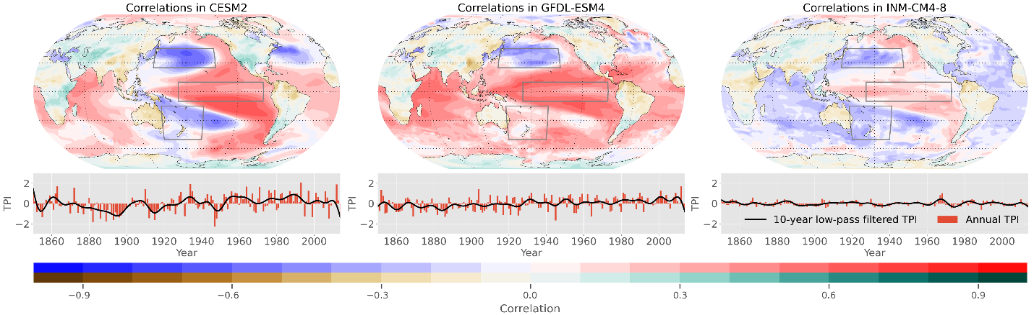

To investigate past and future climate variability in models and reanalyses, we will explore the following datasets:

Last millennium and historical simulations: Many climate simulations have been run over the last millennium (~850 - 1850 CE) or historical (~1850 - 2005 CE) periods. These periods overlap with the years we expect to recover from new bivalve records, allowing us to compare reconstructed patterns and timescales of Pacific variability (and teleconnections with other regions) against climate simulated in models. A collection of historical and last millennium simulations are publicly available, including those run as part of the Coupled Model Intercomparison Project Phase 6 (CMIP6; Eyring et al., 2016) as well as the Community Earth System Model Last Millennium Ensemble (CESM LME; Otto-Bliesner et al., 2016). This collection of simulations, which consists of different temporal and spatial characteristics of Pacific variability (Fig. 6), will allow us to explore model diversity and test a collection of models against observations.

Future warming simulations: Climate models allow us to make predictions of future climate change. Under CMIP6, many of the same models used to simulate the past (e.g., historical simulations) have been used to simulate future climate. Because the same models are used to simulate the past and the future, evaluation of past climate variability can inform our confidence in future projections across a multitude of models, which display differences in predicted Pacific variability (Planton et al., 2021; Fig. 7). Simulations are also run using a range of shared socioeconomic pathways (SSPs; O’Neill et al., 2017), creating predictions for a collection of possible forcing scenarios. The development of new proxy data will help us to better evaluate Pacific variability in model simulations and thereby focus our analysis on the best-performing models, better constraining predictions of the future.

**Figure 7. Monthly Tripole Index in six future simulations.** The monthly Tripole Index calculated in six simulations of the SSP2-4.5 scenario, which represents a “middle-of-the-road” warming scenario (O’Neill et al., 2017). The bottom panel shows a zoomed in view of the final decade, showing the diversity of the Tripole Index among models.

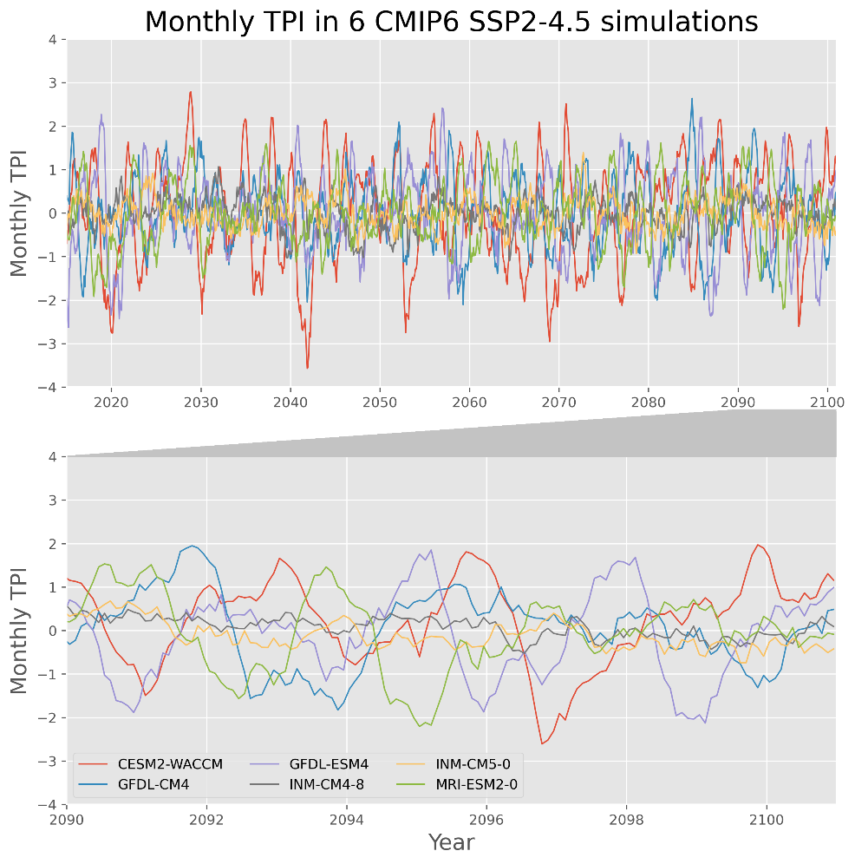

Modern reanalysis products: Modern reanalysis products like the ECMWF’s ERA5 (Hersbach et al., 2020) are typically spatially complete reconstructions of modern climate based on instrumental weather data. Several of these products are publicly available and will allow us to compare recent proxy data against observation-based datasets.

In general, observations can be used to evaluate model results, separating skillful models from those with pronounced shortcomings. By focusing on models which skillfully replicate the past, we can have better-informed predictions of the future. This links past climate data to future climate risk.

**Year 1**

* Gather previously collected and new geoduck specimens from 3 sites
* Build chronologies at all sites
* Sample geoducks for stable isotopes
* Examine climate-growth relationships and build climate reconstructions where possible
* Begin evaluating South Pacific climate variability and teleconnections in models
* Publish the observed *P. zelandica* climate-growth and climate-δ18O relationships at all sites

**Year 2**

* Choose promising site from early work and extend crossdated archive with dead-collected specimens
* Build climate reconstruction from multi-proxy geoduck archive, utilizing radiocarbon measurements for floating chronologies
* Compare South Pacific climate to SSTs in the central and North Pacific to quantify intra-Pacific patterns of climate variability
* Explore teleconnections between Pacific SST patterns and annual climate elsewhere (in tree rings, ice cores, etc.) and models
* Present work at the International Sclerochronology Conference
* Submit a paper about the South Pacific SST reconstruction

**Year 3**

* Employ the New Zealand geoduck multiproxy SST reconstruction alongside other proxies to reconstruct IPO
* Use the pan-Pacific reconstruction to evaluate model skill
* Explore simulated future changes in Pacific variability and teleconnection under different forcing scenarios in models
* Submit a paper about past and future Pacific climate variability in data and models, with a focus on challenges to New Zealand fisheries and coastal communities
* Present work at AGU
* Submit a paper about Pacific variability and teleconnections in proxies and models

1. **Broader Impacts**

Our skill assessments of climate models in relation to past IPO variability and teleconnection stability will aid policy makers and resource managers in New Zealand, Australia, and the continental U.S. in making drought and pluvial adaptation decisions based on the best-suited models.

Decadal-scale SST variability around New Zealand is dominated by the IPO, and this climate index is a topic of interest for the government and people of New Zealand in relation to heat waves, pluvials, and droughts (Power et al., 1999; Salinger et al., 2020; Mullan et al., 2010). This project will also directly impact the New Zealand geoduck fishery by providing new data on species longevity across time and space. We will share population age data with geoduck fisheries researchers Lindsey White and Paul Gribben to help improve models of sustainable catch limits for this species (see letters of collaboration).

This work will support the laboratory work and research of undergraduates at both Iowa State University and Northern Arizona University. These students will be included in scientific discourse and paper-writing, as PI Edge has done in the past (2021). This project will also support the work of two early career researchers, PI Thatcher and PI Edge.

PI Erb and PI Edge will participate in the Flagstaff Festival of Science. The annual event promotes enthusiasm for science among K-12 students and the broader public. We will visit a public-school classroom to engage students with samples, photos, graphs, and stories.

PI Thatcher has an ongoing relationship with a local high school (Gilbert, IA) and has led one day of activities each year since 2017 for Algebra II classes about natural logs and their utility in radiometric dating of shells, stalagmites and other geologic materials.

**5. Relevance to P4CLIMATE**

Our proposed BIVALVE project will develop new proxy data in the south Pacific, which is relevant for reconstructing local climate and understanding broad-scale variability in the Pacific and beyond. Together with analysis of past and future model simulations, we will investigate Pacific climate variability and its teleconnections to regional climate elsewhere in the world. Our use of proxy and modeling supports the goals of the P4CLIMATE program, and this project particularly espouses one of the primary themes of P4CLIMATE, which is to understand “past regional and seasonal climate”. By reconstructing Austral summer South Pacific climate variability during the common era, the BIVALVE project will illuminate important regional climate variability in the season of recent extreme heat waves as well as links to the broader climate system.

**6. Roles for personnel**

**Edge** will lead proxy development, including the acquisition of new samples, radiocarbon sampling plan and interpretation, the training of undergraduates in laboratory work, and the processing and interpretation of proxy measurements. He will also interface with collaborators in New Zealand, including fisheries and environmental agencies to facilitate proxy development and educational outreach. He will lead writing on several of the planned papers and present research at international conferences.

**Erb** will lead analysis of model results and modern reanalysis products, connecting the local South Pacific data to broader-scale climate variability. He will contribute to data analysis, paper writing, outreach, and future directions of the project.

**Thatcher** will lead the isotopic analysis, including developing the sampling plan, training of undergraduates in laboratory work, and interpreting the stable isotope data. She will also contribute to data analysis, paper writing, outreach, and future directions of the project.

**7. Results from Previous NSF Support**

**Edge** - No prior support

**Erb** - “Collaborative Research: Quantifying Holocene climate variations through data assimilation using proxies and GCM output” (ASG-1903548, $441,947, 9/1/19-present)

**Intellectual Merit:** Proxy records and climate models are the two primary means of exploring past climate. In this project, we used a method called paleoclimate data assimilation to combine information from these two sources to create a spatially complete reconstruction of temperature over the past 12,000 years. Proxies and models were also used to explore hydroclimate over this same period, providing a new perspective on climate over this vast and historically relevant period.

**Broader Impacts:** Data and code from this project has been publicly released and described in publications and conference talks. This work also helped fund a Ph.D. student at Northern Arizona University. Additionally, this project funded two 2.5-day workshops aimed at teaching early-career researchers about paleoclimate data assimilation, models, and proxies. The first workshop was held in August 2022 and accepted 60 applications from 19 countries. The second was held in August 2023 and accepted 111 applicants from 27 countries.

**Publications:** Kaufman et al., 2020a, Kaufman et al., 2020b, Erb et al., 2022b, and Hancock et al., 2023

**Data and Code:** Data and code has been publicly released for the Holocene temperature reconstruction (data: Erb et al., 2022a, code: Erb et al., 2022c), and data from the hydroclimate analysis has been released (Hancock et al., 2023a). A variety of hydroclimate proxy records were also organized as part of this project, which are available as part of the LiPDverse.

**Thatcher** -“Collaborative Research: Using multi-proxy paleo data to constrain natural and anthropogenic hydrographic variability in the Gulf of Maine System over the last 250 years”  (OCE-MGG-2028197, $733,792, 2020-2024)

**Intellectual merit:** This research used a multipronged approach with geochemical proxies in two types of high-resolution marine climate archives (*Arctica islandica* and crustose coralline algae) to reconstruct past changes in oceanographic conditions, including near surface seawater temperature and salinity in the Gulf of Maine through the last 250 years. We found that the varied contributions of Gulf Stream water to the Gulf of Maine is important in driving recent regional warming.

**Broader Impacts:** This work is informing the Maine Ocean Coastal Acidification Partnership, which is working with the newly formed Marine Climate Council of state legislators to develop a Maine Ocean Acidification Action Plan. It is supporting inquiry-based coursework and research opportunities for undergraduates, collaboration at local K-12 schools, and is providing collaborative mentoring for 10 undergraduate students, two post-baccalaureate students, two graduate students and a postdoctoral researcher. Additionally, a Science Communication workshop was held at Bowdoin College in Summer 2023 for 10 undergraduate students from three institutions.

**Products:** The research has generated two master’s theses, two senior theses and been presented at national and international conferences. Five publications are currently in preparation. Once published, data will be available from the National Centers for Environmental Information.